**Ideation Phase**

**Define the Problem Statements**

| Date | 19 September 2022 |
| --- | --- |
| Team ID | PNT2022TMID32347 |
| Project Name | Smart Fashion Recommender System |
| Maximum Marks | 2 Marks |

**Customer Problem Statement Template:**

**Smart Fashion Recommender System:**

**#1 problem**

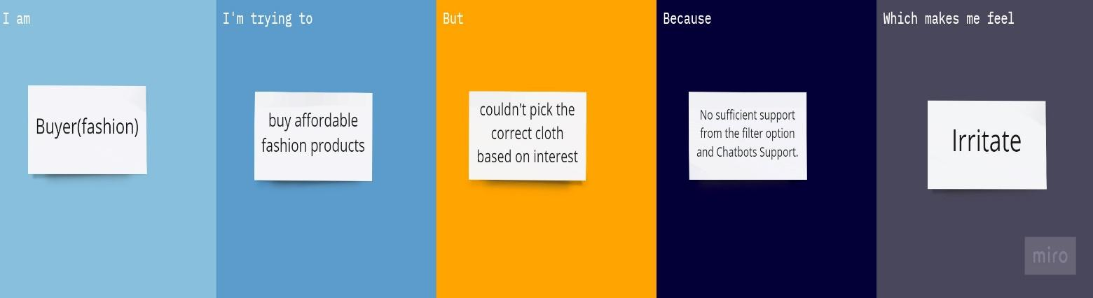

#**2 problem**

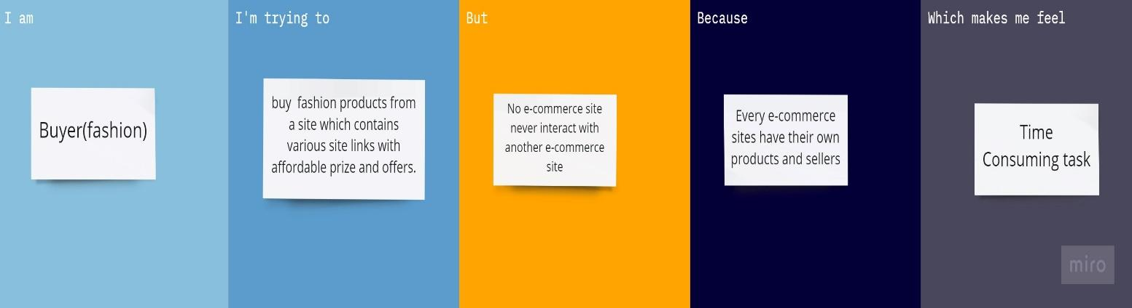

| **Problem Statement (PS)** | **I am (Customer)** | **I’m trying to** | **But** | **Because** | **Which makes me feel** |
| --- | --- | --- | --- | --- | --- |
| PS-1 | Buyer(fashion) | Buy affordable fashion products | Couldn’t pick the correct cloth based on interest | No sufficient support from the filter option and Chatbots Support. | Irritate |
| PS-2 | Buyer(fashion) | Buy fashion products from a site which contains various site links with affordable prize and offers | No e-commerce site never interact with another e-commerce site | Every e-commerce sites have their own products and sellers | Time Consuming task |